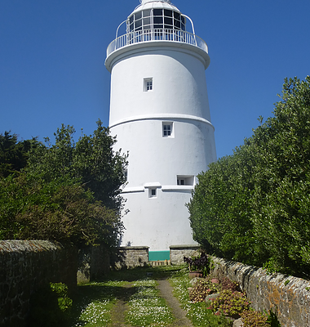
St Agnes is the most isolated of the inhabited islands in the Isles of Scilly, separated from St Mary's by the deep channel of St Mary’s Sound. At almost every turn the view is dominated by the magnificent 17th century lighthouse, which continues to serve as a daymark for shipping in the western approaches.

St Agnes is best enjoyed outdoors and is a real adventure playground for the explorer with a wealth of Bronze Age monuments from standing stones to burial chambers and there are the most incredible rock formations on the western coastline, although perhaps the best, the Nag’s head, so named because it looks like the head of a horse, lies inland standing 15ft tall in wonderful isolation.
That said, Gugh has plenty of treats of its own and a circular walk is highly recommended but do check the tides before you set off as you may end up being there overnight and unlike St Agnes, with it’s friendly pub situated by the quay, two cafes and shop, you might find yourself getting very hungry indeed.

St Agnes offers a wealth of visual treats and ample refreshment for the visitor and as a holiday destination it provides an idyll of calm isolation that is hard to beat anywhere in the world.
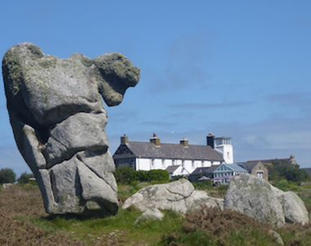
Like most of Scilly, St Agnes attracts a large number of migrating and resident birds, including the much loved puffin and, as a result of the world's largest community-led project to restore seabird populations by the removal of rats, the island has now been officially declared rat-free which has led to Manx Shearwaters and European Storm Petrels breeding on the island.

St Agnes is linked to the island of Gugh by a narrow sandbar that is fully covered at high tide and with there being two houses on Gugh it means there are actually six inhabited islands in the archipelago although Gugh tends to be counted as one with St Agnes.
