St Martin's has arguably the finest beaches on the Isles of Scilly so it is little wonder that it is such a popular holiday destination for people of all ages and an ideal romantic hideaway. The island itself is quite narrow and stretches for around two miles and the road connecting the island's two quays is adorned by three small settlements appropriately named Higher Town, Middle Town and Lower Town.

The most striking landmark is the 17th century daymark on St Martin's Head with its distinctive red and white hoops but it is the beautiful and contrasting terrain that offers the greatest delight to the explorer.
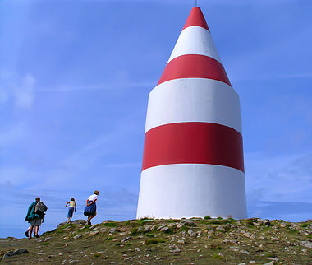
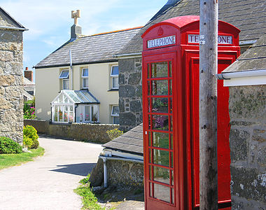
There is plenty on offer to the visitor from the vineyard to the flower farm, snorkelling with seals and the St Martin's Dive School which offers some of the finest diving in the UK with over 155 dive sites located and many new ones added each year. For the arts and crafts enthusiast there is the North Farm Gallery and the jewellery workshop.

The culinary offer includes great variety including lunch practically on the beach at the Karma Hotel, the Sevenstones Inn provides a meal with a view, there is also the Polreath Tea Room, The Island Bakery, Little Arthur Farm Cafe and Bistro and fish and chips from locally caught fish and home-grown potatoes. In short, there is something for everybody but if it's a romantic idyll you seek then you will be hard pushed to find somewhere better in the United Kingdom.
Cultivated land from the centre of the island runs down to sand dunes on the southern and western coasts an is adorned with exotic plants growing wildly from the walls and hedgerows bordering the small fields of vegetables and flowers.

To the north east lies a more rugged, weather-beaten coastline that nature intended, the crowning glory of which has to be the secluded tranquillity of the magnificent and utterly unspoilt beach at Great Bay which offers perfect bathing in its shallow turquoise waters.
