St Mary’s is the largest island in the Isles of Scilly archipelago and despite being just 3 miles across at its widest point it dwarfs all neighbouring islands by some distance. It is the hub of the islands and provides many of the essential services required by those living on the neighbouring islands of Bryher, St Agnes, St Martin's and tresco.
​
It is also home to just over three quarters of the entire islands’ population with around 1700 inhabitants, of which approximately 1100 live in the main settlement of Hugh Town, which is built on a narrow isthmus connecting the Garrison peninsula to the main island.
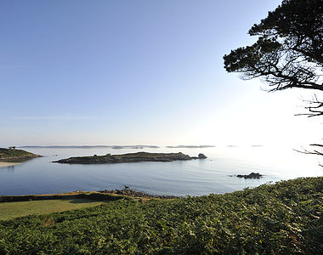
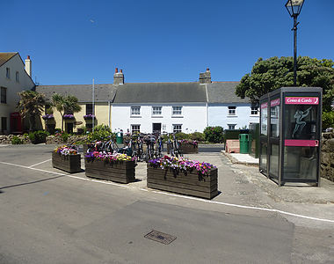
With a hospital, health centre, emergency services, shops, pubs and restaurants, Hugh Town has a wealth of facilities that would be the envy of any town of similar size and population anywhere in the world. This owes much to the isolation of the archipelago, which is slightly further from Land’s End than the Dover-Calais crossing between England and France, and helps to make the Isles of Scilly such a unique place.

Hugh Town is very much a working town with its busy harbour, shops and businesses and although picturesque, the real beauty of St Mary’s lies outside of town in what is termed ‘up country’ by the locals.
The contrasting scenery of St Mary’s is a joy to behold and a profusion of exotic flora and wildlife can be witnessed at every turn through the heathland, woodland and marsh that the diverse landscape offers.

The St Mary’s coastline stretches for around 9 miles and can be explored in a day although it will take several walks to take everything in. You will be amazed by how few people you encounter as unlike a typical seaside holiday destination, where thousands head for the same stretch of coastline, the circular nature of the island provides a different starting point for everyone.

It will always seem much quieter than it actually is so don’t be surprised if you find a sandy beach all to yourself in this incredible island that lies truly in the heart of paradise.
