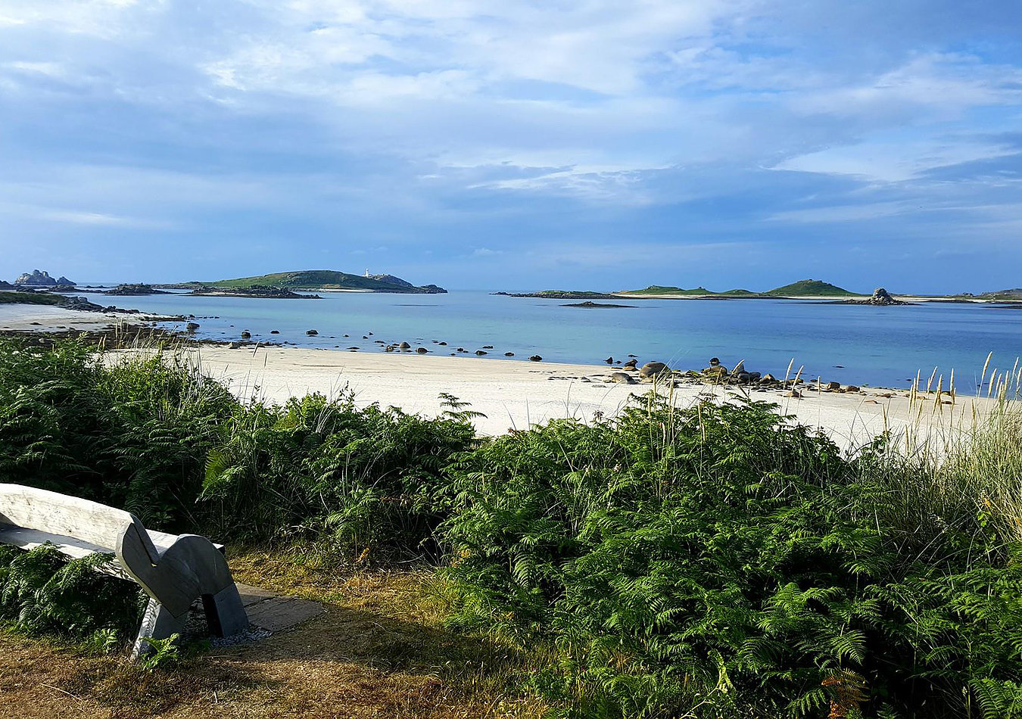

Tresco
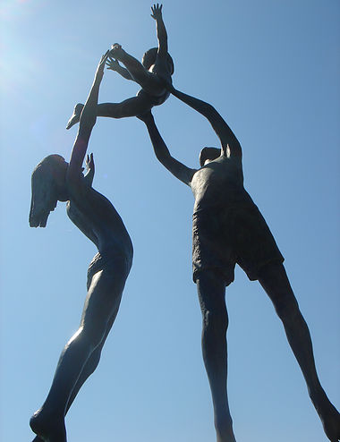
Tresco is the second largest island in the Isles of Scilly archipelago, approximately half the size of St Mary's and the most naturally sheltered, with Bryher close by to the west and St Martin's to the east.
​
The rugged heathland to the North of the island would not look out of place in the north of Scotland while the remainder of the island, with it's sub-tropical Abbey Garden, white sandy beaches and pristine landscape, is a world away from anywhere in the United Kingdom.
There is so much more to Tresco than flowers. The island offers something for everyone with its 17th Century Cromwell's Castle and the 16th century Block House, to the tin mining pits on Castle Down, the magnificent sculptures of David Wynne and the picturesque beaches at Pentle Bay, Cook's Porth and Appletree Bay. There is genuine treasure at every turn. Two freshwater pools - Abbey Pool and Great Pool - provide an excellent vantage point for the birdwatcher, the terrain offers great variety underfoot and spectacular views for the walker and the quiet roads are perfect for the cyclist.

Tresco oozes quality of the very highest order when it comes to holiday accommodation and catering provision and the setting serves to enhance the experience. Whether you stay for the week or visit for the day you can be sure of an unforgettable and luxurious holiday in a genuine Garden of Eden.
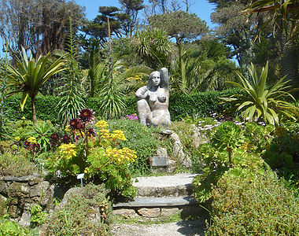
It is of course the Abbey Garden that Tresco is most famous for. The shores of Scilly are washed by the Gulf Stream and ensure a virtually frost-free environment which allows for so many exotic plants to thrive, including Agaves, Aloes and the fabulous Proteas. The islands remain prone to salt-laden gales from the Atlantic, however, so the garden is protected by striking shelter belts of Monterey pine and Monterey cypress which be seen from virtually anywhere on Scilly, creating micro-climates within the garden and further enhancing the status of Tresco Abbey Garden as a world-class visitor attraction.
