Being the island of hills it is not surprising that Bryher boasts the best vantage point in the archipelago. From the top of the aptly named Watch Hill you can see all the way across Tresco and over into St Martin’s as well as enjoying clear views of St Mary’s and St Agnes.

The charming village in the centre of the island has an excellent shop and a café and together with Hell Bay Hotel and Fraggle Rock bar they ensure there is plenty of refreshment on offer to the visitor who will always be guaranteed a warm welcome and end up wishing they could stay longer.
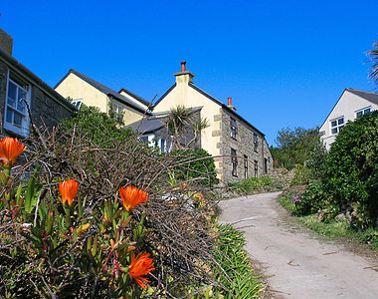
The wild beauty of the Isles of Scilly can be witnessed at its best on Bryher, the island of hills and home to the smallest community on the islands. Bryher is an island of extremes, situated a few metres to the west of Tresco and some 2,200 miles to the east of Newfoundland and Labrador Province, Canada.

On the western shore is the notorious Hell Bay, so named for the furious crashing waves that come rolling in from the Atlantic at the end of their trip from the Americas to the detriment of many a mariner, while the eastern shore offers the calm crystal clear water of the Tresco Channel.
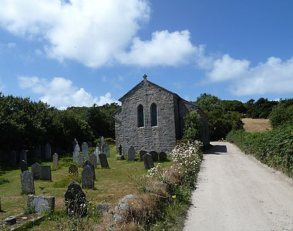
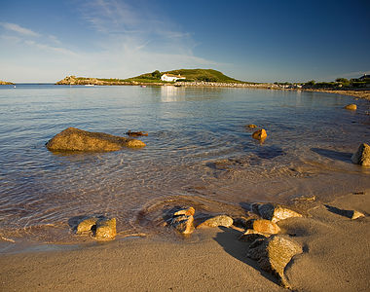
Tranquillity abounds in the south eastern shores where the beautiful sheltered beach at Rushy Bay looks out towards the neighbouring uninhabited island of Samson while at the opposite end of the island you’ll find the heathland, rock formations and prehistoric boulder walls of Shipman Head Down which are a haven for the birdwatcher and a delight for the explorer.
​
Bryher is a genuine holiday paradise, a break from the norm where you can do as much or as little as you want. There are regular boats to the other islands and you can even hire your own boat, but there is plenty to see and do and even in wet weather the fabulous community centre provides a range of games and activities to keep you occupied.

